## **Across SSPs with Historical Data for one model**

## **MODEL – CanESM5**

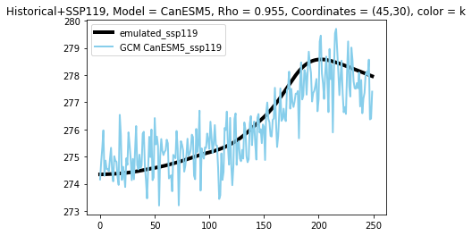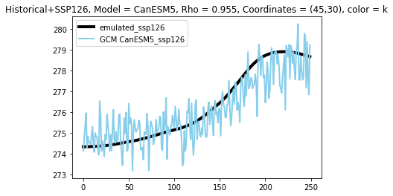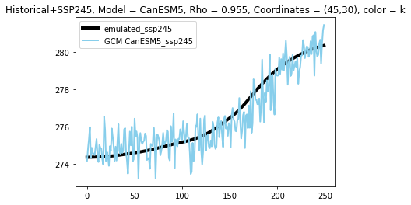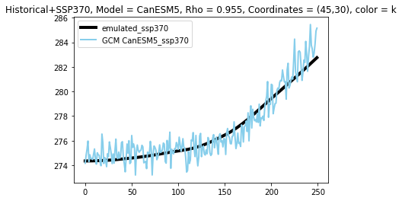

## **Across SSPs with Historical Data for one model**

## **MODEL – MIROC6**

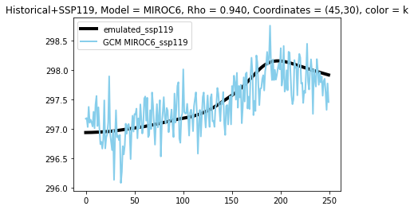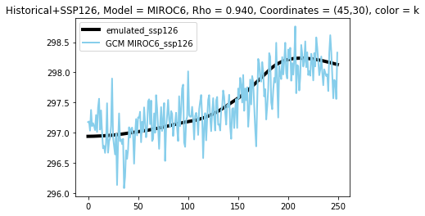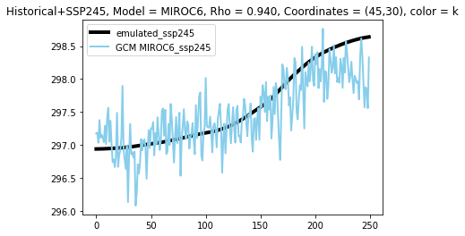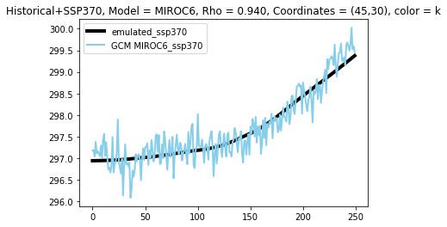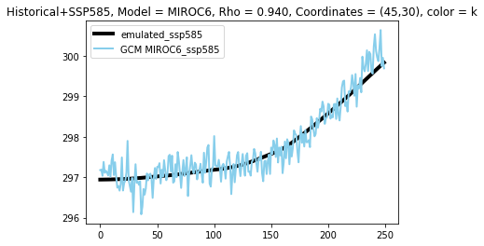

## **Across SSPs with Historical Data for one model**

## **MODEL – KACE-1-0-G**

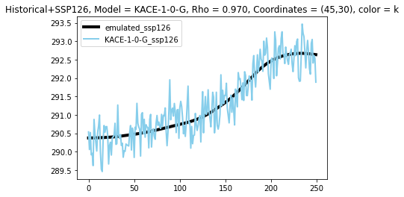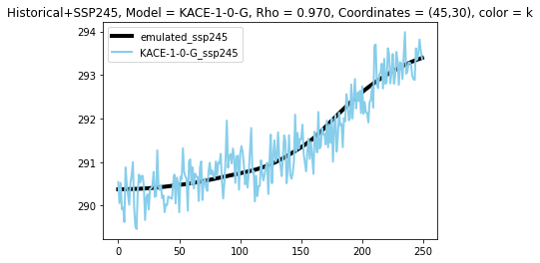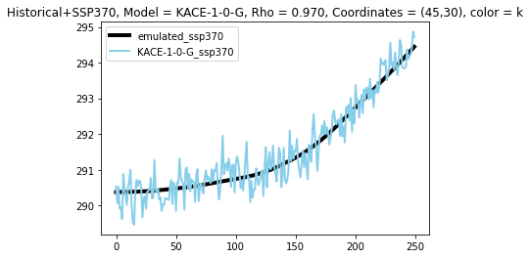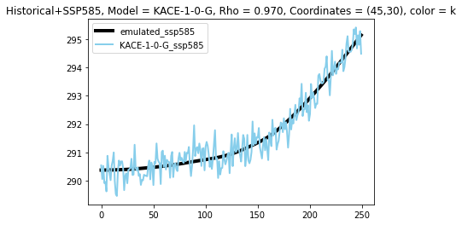

**Across SSPs with Historical Data for one model**

**MODEL – MRI-ESM-2**

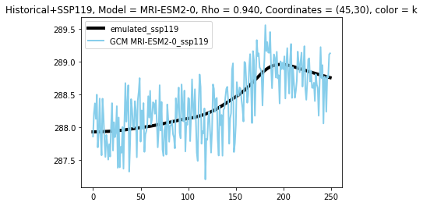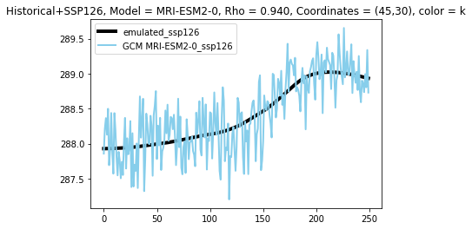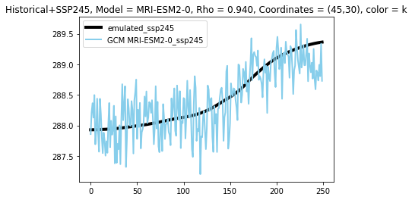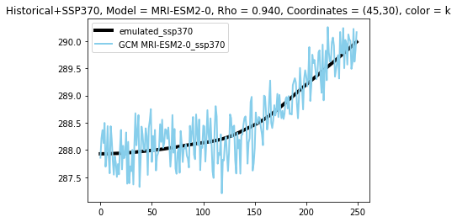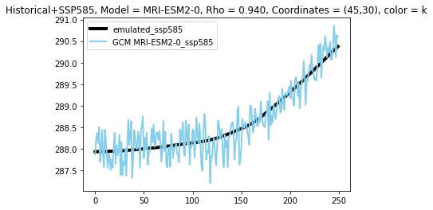

## **Across models in one SSP with historical data**

## **SSP – 119**







## **Across models in one SSP with historical data**

## **SSP – 126**







## **Across models in one SSP with historical data**

## **Across models in one SSP with historical data**

## **SSP – 370**



## **Across models in one SSP with historical data**

## **SSP - 585**

SOUTHERN OCEAN REGION

